LAB EXPERIMENTS
CSA-0411

OPERATING SYSTEMS LAB

Name | Vishal balaji J
Register Number | 192525014
Course Code | CSA-0411

Experiments included: process identification, file copying with system calls, FIFO page replacement simulation, Java multithreading, and CPU scheduling algorithms.

EXPERIMENT 1: PROCESS ID AND PARENT PROCESS ID
Aim: To write a C program that displays the process ID of the currently running process and its parent process ID using system calls.
Procedure:
- Include the required header files: stdio.h and unistd.h.
- Call getpid() to obtain the current process ID.
- Call getppid() to obtain the parent process ID.
- Display both values using printf() and terminate the program.
Source Code:
#include <stdio.h>
#include <unistd.h>
int main(void) {
printf("Process ID: %d\n", getpid());
printf("Parent Process ID: %d\n", getppid());
return 0;
}
Output:The process IDs are assigned by the operating system and may differ each time the program runs.
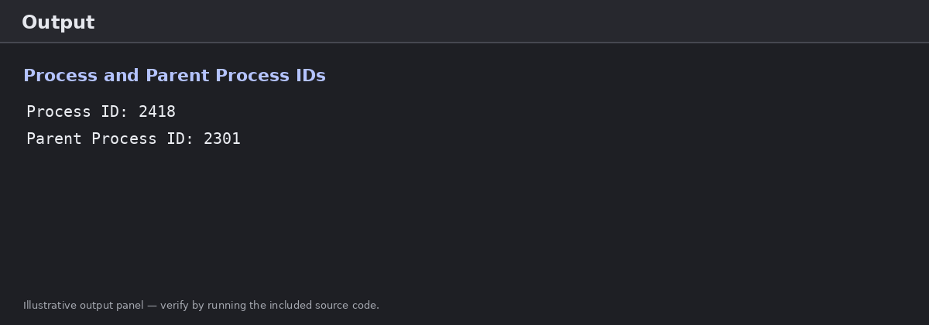
Figure 1. Illustrative output panel for Experiment 1.
Result: The program displays the current process ID and parent process ID successfully.

EXPERIMENT 2: COPY A FILE USING SYSTEM CALLS
Aim: To write a C program to copy the contents of one file to another using open(), read(), write() and close().
System calls used: open() opens a file, read() reads data, write() writes data, and close() closes a file descriptor.
Procedure:
- Open the source file in read-only mode.
- Create or open the destination file in write mode.
- Read data from the source file into a buffer.
- Write the bytes read into the destination file, repeating until the source reaches the end.
- Close both files and report success. Check errors before continuing.
Source Code:
#include <stdio.h>
#include <stdlib.h>
#include <fcntl.h>
#include <unistd.h>
int main(void) {
int src, dest;
ssize_t n;
char buffer[100];
src = open("source.txt", O_RDONLY);
if (src < 0) {
perror("Cannot open source.txt");
return 1;
}
dest = open("destination.txt",
O_WRONLY | O_CREAT | O_TRUNC, 0644);
if (dest < 0) {
perror("Cannot open destination.txt");
close(src);
return 1;
}
while ((n = read(src, buffer, sizeof(buffer))) > 0) {
ssize_t written = 0;
while (written < n) {
ssize_t w = write(dest, buffer + written, n - written);
if (w < 0) {
perror("Write failed");
close(src);
close(dest);
return 1;
}
written += w;
}
}
if (n < 0) {
perror("Read failed");
close(src);
close(dest);
return 1;
}
close(src);
close(dest);
printf("File copied successfully.\\n");
return 0;
}
Note: Create source.txt in the program's working directory before running. The program creates destination.txt.
Output:If source.txt is available and the copy completes, the program prints the success message.
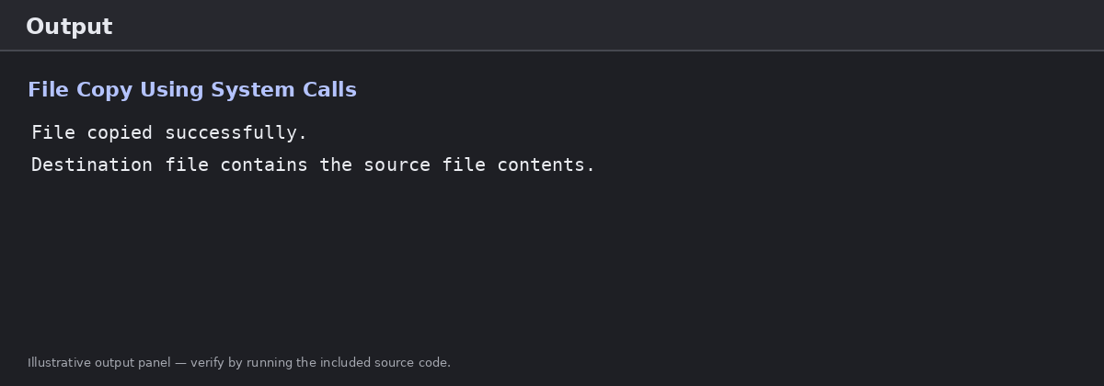
Figure 2. Illustrative output panel for Experiment 2.
Result: The file-copying program uses system calls to copy the source file into the destination file.

EXPERIMENT 3: BUFFER MANAGEMENT USING FIFO PAGE REPLACEMENT
Aim: To simulate buffer/page-frame management using the First-In, First-Out (FIFO) page replacement method and count page hits and page faults.
Procedure:
- Initialize three page frames as empty.
- Read the page reference string one page at a time.
- If the page is already present in a frame, count a hit.
- Otherwise, count a page fault and replace the oldest page using FIFO.
- Display the page hit and page fault totals.
Source Code:
#include <stdio.h>
int main(void) {
int pages[] = {1, 2, 3, 2, 1, 4, 2, 5, 1};
int n = sizeof(pages) / sizeof(pages[0]);
int frames[3] = {-1, -1, -1};
int next = 0, hits = 0, faults = 0;
for (int i = 0; i < n; i++) {
int found = 0;
for (int j = 0; j < 3; j++) {
if (frames[j] == pages[i]) {
found = 1;
break;
}
}
if (found) {
hits++;
} else {
frames[next] = pages[i];
next = (next + 1) % 3;
faults++;
}
printf("Page %d: ", pages[i]);
for (int j = 0; j < 3; j++) {
if (frames[j] == -1) printf("- ");
else printf("%d ", frames[j]);
}
printf("\\n");
}
printf("Total page hits: %d\\n", hits);
printf("Total page faults: %d\\n", faults);
return 0;
}
Output:For the reference string shown in the code and three frames, the output lists frame contents after each page reference, followed by the hit and fault totals.
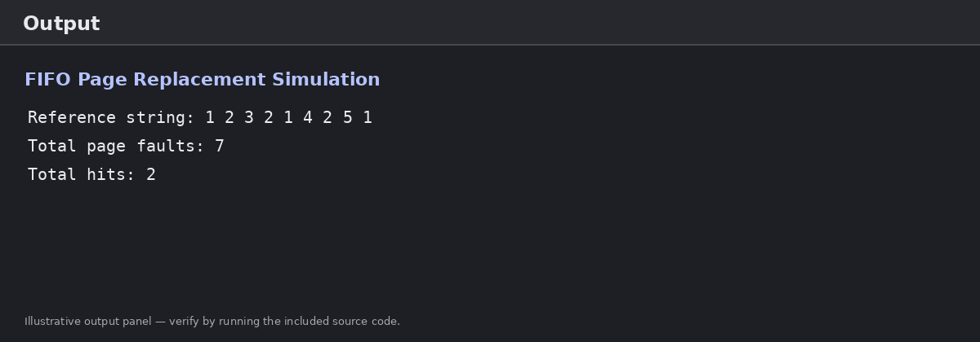
Figure 3. Illustrative output panel for FIFO page replacement.
Result: The FIFO page replacement simulation tracks page hits and page faults for the given reference string.

EXPERIMENT 4: JAVA MULTITHREADING USING THE THREAD CLASS
Aim: To implement multithreading in Java by creating and executing two threads.
Materials Required: Computer, Java Development Kit (JDK), Java IDE or text editor, and terminal/command prompt.
Procedure:
- Create a class that extends Thread and override its run() method.
- Inside run(), print the current thread name and a counter.
- Create two thread objects and assign them different names.
- Call start() on both objects to begin concurrent execution.
- Observe that the order of the printed lines may vary between runs.
Source Code:
class MyThread extends Thread {
public void run() {
for (int i = 1; i <= 5; i++) {
System.out.println(
Thread.currentThread().getName() + ": " + i);
}
}
}
public class MultithreadDemo {
public static void main(String[] args) {
MyThread t1 = new MyThread();
MyThread t2 = new MyThread();
t1.setName("Thread 1");
t2.setName("Thread 2");
t1.start();
t2.start();
}
}
Output:Both threads print values from 1 to 5. The exact interleaving can vary because thread scheduling is handled by the runtime and operating system.
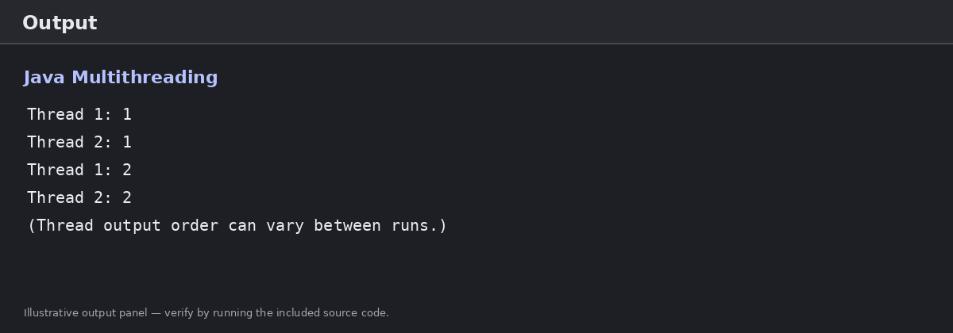
Figure 4. Illustrative output panel for Experiment 4.
Result: Multithreading is implemented successfully using the Thread class and start() method.

EXPERIMENT 5: CPU SCHEDULING ALGORITHMS
Aim: To implement FCFS, Shortest Job First (SJF), Round Robin (RR) and non-preemptive Priority Scheduling in C, and calculate waiting time and turnaround time.
Algorithms included: FCFS (First Come First Serve), SJF (non-preemptive), Round Robin (time quantum 2), and Priority Scheduling (non-preemptive; lower number means higher priority).
Procedure:
- Read the number of processes and their burst times. For Priority Scheduling, also read priorities.
- For FCFS, execute processes in their input order.
- For SJF, execute the process with the shortest burst time first.
- For Round Robin, give each ready process a time slice of 2 units until all processes finish.
- For non-preemptive Priority Scheduling, execute the highest-priority process first.
- Calculate waiting time and turnaround time for each process, then display the averages.
Source Code:
#include <stdio.h>
#define MAX 20
void show(const char *name, int n, int bt[], int wt[], int tat[]) {
float awt = 0, atat = 0;
printf("\\n%s\\n", name);
printf("P\\tBT\\tWT\\tTAT\\n");
for (int i = 0; i < n; i++) {
printf("P%d\\t%d\\t%d\\t%d\\n", i + 1, bt[i], wt[i], tat[i]);
awt += wt[i];
atat += tat[i];
}
printf("Average waiting time: %.2f\\n", awt / n);
printf("Average turnaround time: %.2f\\n", atat / n);
}
int main(void) {
int n, bt[MAX], wt[MAX], tat[MAX], rem[MAX], pr[MAX], order[MAX];
int quantum = 2;
printf("Enter number of processes (1-%d): ", MAX);
if (scanf("%d", &n) != 1 || n < 1 || n > MAX) return 1;
for (int i = 0; i < n; i++) {
printf("Burst time for P%d: ", i + 1);
if (scanf("%d", &bt[i]) != 1 || bt[i] < 1) return 1;
order[i] = i;
rem[i] = bt[i];
}
/* FCFS */
wt[0] = 0;
for (int i = 1; i < n; i++) wt[i] = wt[i-1] + bt[i-1];
for (int i = 0; i < n; i++) tat[i] = wt[i] + bt[i];
show("FCFS", n, bt, wt, tat);
/* Non-preemptive SJF: sort process indexes by burst time */
for (int i = 0; i < n; i++) order[i] = i;
for (int i = 0; i < n-1; i++)
for (int j = i+1; j < n; j++)
if (bt[order[j]] < bt[order[i]]) {
int tmp = order[i]; order[i] = order[j]; order[j] = tmp;
}
int elapsed = 0;
for (int k = 0; k < n; k++) {
int p = order[k];
wt[p] = elapsed;
tat[p] = wt[p] + bt[p];
elapsed += bt[p];
}
show("SJF (non-preemptive)", n, bt, wt, tat);
/* Round Robin with quantum = 2; all processes arrive at time 0 */
for (int i = 0; i < n; i++) rem[i] = bt[i], wt[i] = 0;
int time = 0, done;
do {
done = 1;
for (int i = 0; i < n; i++) {
if (rem[i] > 0) {
done = 0;
int run = rem[i] < quantum ? rem[i] : quantum;
time += run;
rem[i] -= run;
if (rem[i] == 0) tat[i] = time;
}
}
} while (!done);
for (int i = 0; i < n; i++) wt[i] = tat[i] - bt[i];
show("Round Robin (q = 2)", n, bt, wt, tat);
/* Non-preemptive Priority; lower priority number = higher priority */
for (int i = 0; i < n; i++) {
printf("Priority for P%d (lower number = higher priority): ", i + 1);
if (scanf("%d", &pr[i]) != 1) return 1;
order[i] = i;
}
for (int i = 0; i < n-1; i++)
for (int j = i+1; j < n; j++)
if (pr[order[j]] < pr[order[i]]) {
int tmp = order[i]; order[i] = order[j]; order[j] = tmp;
}
elapsed = 0;
for (int k = 0; k < n; k++) {
int p = order[k];
wt[p] = elapsed;
tat[p] = wt[p] + bt[p];
elapsed += bt[p];
}
show("Priority (non-preemptive)", n, bt, wt, tat);
return 0;
}
Input notes: All processes are assumed to arrive at time 0. Enter a burst time for each process, then enter a priority for each process when prompted. For priority scheduling, a smaller priority number represents a higher priority.
Output:The program displays a table for each scheduling method, including burst time (BT), waiting time (WT), turnaround time (TAT), and average values.
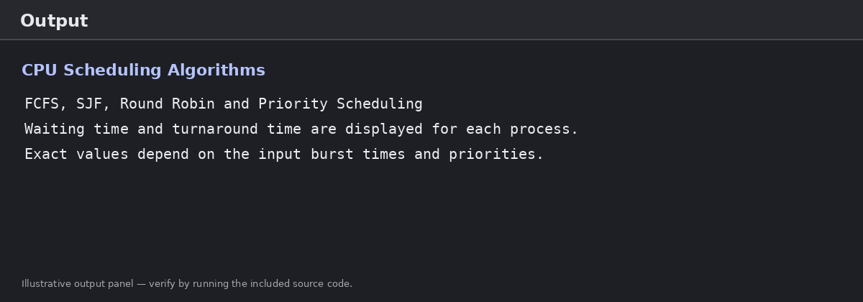
Figure 5. Illustrative output panel for Experiment 5; actual numeric results depend on entered values.
Result: The four CPU scheduling methods are implemented and their waiting-time and turnaround-time results are displayed.

GENERAL NOTES
- The process-ID program and file-copy program use POSIX system calls and should be compiled in a Linux/Unix environment or a compatible environment such as WSL.
- The file-copy experiment requires a source.txt file in the working directory.
- The Java source file should be saved as MultithreadDemo.java because that is the public class name.
- Output images in this document are illustrative, neatly formatted output panels based on the submitted online-compiler reference. They are not screenshots of a verified live compiler run.
- Run each source code in the lab environment and replace the illustrative output panel with an actual compiler screenshot if your instructor requires proof of execution.

